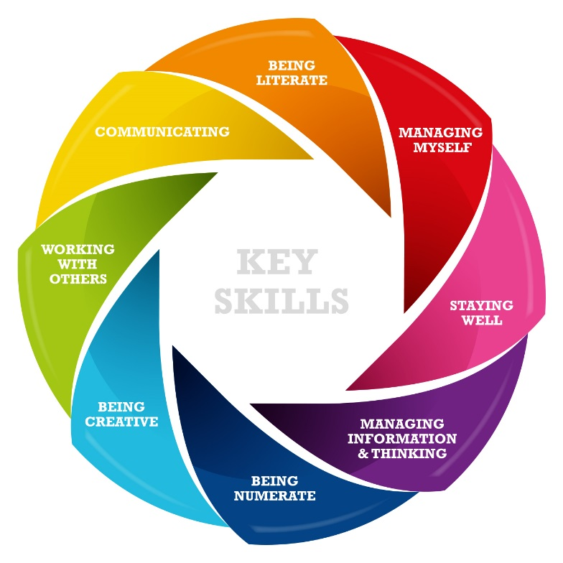

JUNIOR CYCLE PROFILE OF ACHIEVEMENT (JCPA)

Handbook for Schools 2023

December 2023

Contents
Part 1 Introduction 4
1.1 What is the purpose of this Handbook? 4
1.2 What is the Junior Cycle Profile of Achievement (JCPA)? 4
1.3 What is the rationale behind the awarding of the JCPA? 4
1.4 How does ongoing reporting link to the JCPA? 5
1.5 What information on student achievement will already have been reported on to students/parents in advance of students receiving the JCPA? 5
1.6 How does the JCPA differ from the old Junior Certificate? 5
1.7 What information is required by the school on PPOD for the JCPA? 5
PART 2 Content and format of the JCPA 6
1.8 When will the JCPA be awarded to students in 2023? 6
1.9 What will appear on the JCPA in 2023? 6
1.10 How many short courses can a school offer in its Junior Cycle Programme? 6
1.11 What if a school has offered more than four Short Courses for students who are due to receive their JCPA in 2023? 6
1.12 Do all JCPAs follow the same format? 6
1.13 How does the JCPA reflect the school identity? 7
1.14 Our Year Head for Third Year changes each year. Is it possible to change signatures for inclusion in the JCPA for PPOD schools each year? 7
1.15 Our school does not have a Year Head? 7
PART 3 Populating the JCPA 7
1.16 How is data inputted to the JCPA? 7
1.17 How does a school produce a completed JCPA where some of the assessment data for a student is missing? 8
1.18 Can students appeal the results and assessment descriptors on the JCPA? 9
1.19 Do schools need to input data on students’ achievements in (CBAs) onto the JCPA? 9
1.20 Do schools need to input data on students’ final examination results on to the JCPA? 9
1.21 Will information be provided on how to enter data? 9
1.22 Will the process to enter data be manageable? 9
1.23 How do schools input information regarding ‘Other Areas of Learning’ and ‘Other Areas of Wellbeing’ on the JCPA? 9
1.24 What kind of learning is reported in the other areas of learning section? 10
1.25 How should a school decide what aspects of a students’ Other Areas of Learning should be reported on in the JCPA? 11
1.26 How is data relating to students’ Other Areas of Learning gathered and stored? 11
1.27 How many references to different learning should a school include on the JCPA under Other Areas of Learning? 12
1.28 How should a school decide what aspects of a students’ Other Areas of Wellbeing should be reported on in the JCPA? 12
1.29 How is data relating to students’ Other Areas of Wellbeing gathered and stored? 12
1.30 Will the DoE have access to the information in the Other Areas of Learning and Other Areas of Wellbeing sections? 12
1.31 How does the Junior Certificate School’s Programme (JCSP) fit with the JCPA? 13
1.32 How will schools enter student achievements in Level 2 Learning Programmes (L2LPs), where relevant? 13
PART 4 Generating the JCPA 15
1.33 How is the JCPA generated? 15
1.34 Are schools required to have the JCPA printed by a professional printing company? 15
DATA PROTECTION 15
1.35 Are there data protection issues for consideration by schools? 15
1.36 Will a copy of the JCPA be saved electronically on a school’s IT system? 16
1.37 Will schools be required to keep copies of JCPAs for their students? 16
Appendix 1 – Checklist for Schools 17
Appendix 2 – Logos and Signatures 18
Appendix 3 – Privacy Notice and Consent Form 20
Appendix 4 – Sample JCPAs 24

Part 1 Introduction

What is the purpose of this Handbook?

The purpose of this handbook is to support schools in their understanding and production of the Junior Cycle Profile of Achievement (JCPA). It provides details on how to complete the JCPA for students who sat the Junior Cycle examinations in 2023, including any changes that have occurred since JCPAs were first awarded in 2017, so that it can be awarded to students before the end of this calendar year. JCPAs will be awarded to all students by schools commencing from 18th December 2023. All JCPAs should be produced and awarded to students by 24th February 2024

As required, updated versions of this document will be published on the Department’s website and a notification will appear on Esinet to this effect.

What is the Junior Cycle Profile of Achievement (JCPA)?

As part of the Framework for Junior Cycle (2015) the reporting process at junior cycle culminates in the award of the JCPA to students. The JCPA was awarded for the first time to students who completed Junior Cycle in 2017. The school will be required to print out the JCPA for each student. It will report on student achievement across a broad range of areas of learning in Junior Cycle. The JCPA, alongside other reporting arrangements in Junior Cycle, will offer students/teachers/parents/guardians a clear, broad picture of a child’s learning journey over the three years of junior cycle.

In the majority of cases, the JCPA will report on student achievement relating to subjects and short courses that are broadly aligned with Level 3 of the National Framework of Qualifications (NFQ).

In some cases, the JCPA may report on achievement for students in the low mild to high moderate range of general learning disabilities where the educational needs of these students are such as to prevent them from accessing some or all of the junior cycle Level 3 subjects and short courses. These students may be engaging with/participating in Level 2 Learning Programmes, or part thereof, which are broadly aligned with Level 2 of the NFQ.

Level 1 Learning Programmes, introduced in 2019, address the learning needs of a very small number of students in the low moderate, and severe and profound range of general learning disabilities. These students are, in almost all cases, enrolled in special schools rather than mainstream schools.

What is the rationale behind the awarding of the JCPA?

The JCPA captures student achievements in a number of assessment elements undertaken over the three years of junior cycle, including the grades in the state-certified final examinations at the end of the three years. It will also report on students’ achievement in Classroom-Based Assessments (CBAs) in subjects and short courses, and in Level 2 Learning Programmes (L2LPs) and achievements in Level 1 Learning Programmes (L1LPs). The JCPA also includes reporting on Wellbeing.
The JCPA will also provide an opportunity for schools to comment on student achievement, participation or progress in other areas of learning that may have been included in the school’s Junior Cycle programme.

How does ongoing reporting link to the JCPA?

Throughout a student’s time in junior cycle, the school will report to parents/guardians on the progress he or she is making. Typically, ongoing reporting of this nature will include written reports at Christmas and in the summer during first and second years.
Feedback from stakeholders during consultation organised by the National Council for Curriculum and Assessment (NCCA) highlighted the need for consistency and coherence in the way reporting on student progress and achievement is made across the three years of Junior Cycle, culminating in the award of the JCPA.
This consistency will be best achieved when the JCPA builds on the same key principles as the school’s process for ongoing reporting of student progress. These principles involve aiming to encourage authentic engagement with parents. Similarly, reporting through the JCPA should aim to clearly communicate students’ progress in learning, provide information on a broad range of achievement, take an inclusive approach and be sensitive to the self-esteem and general wellbeing of students.
The NCCA has published Guidelines and information on planning for reporting, see https://www.ncca.ie/en/junior-cycle/assessment-and-reporting/reporting

What information on student achievement will already have been reported on to students/parents in advance of students receiving the JCPA?

Reporting at the end of second year will document the achievement of students in Classroom-Based Assessments (CBAs) completed in that year in subjects and short courses and also student achievement in Level 2 Learning Programmes (L2LPs) and Level 1 Learning Programmes (L1LPs), where relevant.

How does the JCPA differ from the old Junior Certificate?

The JCPA is compiled by the school, adhering to a national format. It recognises student achievement, not solely through the state-certified final examinations, but also through a range of other assessment modes and areas of learning. The state certified grades are first reported by the State Examinations Commission (SEC) in provisional form some time following the end of third year. These results are subsequently confirmed and included in the Junior Cycle Profile of Achievement (JCPA) which is produced by schools. A Junior Certificate is no longer issued. The JCPAs are now the only official document containing the final results of the Junior Cycle examinations and schools are the record holders for these.

What information is required by the school on PPOD for the JCPA?

It is essential that a student’s correct personal details along with the subjects that they are studying which have classroom based assessments are recorded on PPOD. If the incorrect personal details are on PPOD then those incorrect details will appear on the JCPA. If a student is studying and sitting an examination for a subject which has a Classroom Based Assessment then this must be recorded on PPOD in the students 2nd year and 3rd year enrolments otherwise this subject will not appear on their JCPA.

PART 2 Content and format of the JCPA

When will the JCPA be awarded to students in 2023?

Schools are required to award JCPAs to all students in the week commencing 18th December. Presentation of the JCPAs should be completed by the end of the 24th February.

What will appear on the JCPA in 2023?

The JCPA in 2023 will report on achievement across all areas of learning as applicable including:
- The student’s achievements in the state-certified final examinations (inclusive of the Assessment Task)
- The student’s achievements in the Classroom-Based Assessments in subjects and short courses, where relevant
- The student’s achievement in other areas of learning and wellbeing.
- The student’s achievements in Level 2 Learning Programmes (L2LPs) and Level 1 Learning Programmes (L1LPs), where relevant.

How many short courses can a school offer in its Junior Cycle Programme?

Students who undertake one or more of the Wellbeing short courses (CPSE, SPHE and PE) may in addition undertake up to four short courses in other areas of the Curriculum.

What if a school has offered more than four Short Courses for students who are due to receive their JCPA in 2023?

In the unlikely event that a school offered more than four short courses to its students finishing Junior Cycle, student achievement in these courses can be reflected under the Other Areas of Learning Section of the JCPA.

Do all JCPAs follow the same format?

Yes, national templates have been developed. This will ensure consistency across post-primary schools. There are three templates for the JCPA. The general layout of JCPAs for 2023 is as the same as those used in the previous JCPA, in 2022.

Template 1
In the majority of cases, students in 2023 will receive a JCPA which reports on students’ achievement in:

- The subjects they took in the state-certified examinations;
- Classroom-Based Assessments (CBAs) for subjects and short courses;
- Wellbeing (PE, CPSE, SPHE);
- Other areas of learning;
- Other areas of Wellbeing;

Template 2
A second template has been developed to report on the small number of cases where students are studying Level 2 Learning Programmes (L2LPs) or Level 1 Learning Programmes (L1LPs) exclusively.

Template 3
A third JCPA template is available to report on the achievements of those students who may study a Level 2 Learning Programme but who also take a small number of subjects in the state-certified examinations.

Examples of JCPAs for 2023 can be found in Appendix 1 of this manual.

How does the JCPA reflect the school identity?

The school crest and signatures of principal and year head will appear on the JCPA if the school provides these to the Department. In order for your school crest and signatures to appear on the JCPAs issued by your school please follow the guidelines attached at Appendix 2. Please ensure that a good quality image is used. If your school submitted a crest and signature in the past which is still valid, then it is not necessary to resubmit these. The signature and logo submitted in the past will automatically be included on JCPAs produced by your school in 2023.

Our Year Head for Third Year changes each year. Is it possible to change signatures for inclusion in the JCPA for PPOD schools each year?

Yes, the school can supply a new signature when needed. If you would like to make changes to the crest or signatures that were submitted in 2022 please complete the template at Appendix 2 and send to jcpa@education.gov.ie as soon as possible. Please include the school roll number and exam centre number in all correspondence.

Note that the names of both the principal and the year head that will appear in text beside the submitted signatures are extracted directly from the school details on Esinet. Please ensure this is updated to reflect any changes of staff.

Our school does not have a Year Head?

If a year head is not recorded on the PPOD application by the school then the Heading “Year Head” will not appear on the JCPA award.

Principal and Year Head are the only signatures that can be printed on the JCPA. It is not possible to substitute the signature of the Deputy Principal or any other signature for the Year Head.

PART 3 Populating the JCPA

How is data inputted to the JCPA?

The Department’s Post-Primary Online Database (PPOD) facilitates the production of JCPAs for students in mainstream schools that undertake state examinations.

There are three separate data sets on the JCPA:

- SEC data;

- Classroom Based Assessment data for subjects and short courses;

- Data relating to other areas of learning and other areas of wellbeing.

Typically, following the relevant Subject Learning and Assessment Review (SLAR) meeting in a school, subject teachers will maintain a record of their students’ achievements in CBAs in line with schools’ existing reporting practices. The results of the CBAs must also be shown on the PPOD system in order for JCPAs to be produced.

This facility to enter data onto PPOD is currently available for 2023 and a step by step guide is available at https://www.gov.ie/en/collection/7ab67f-post-primary-online-database-ppod-user-guides/

Schools will be able to enter relevant CBA descriptors using a dropdown menu with five descriptors: Exceptional, Above Expectations, In Line with Expectations, Yet to Meet Expectations, and Not Reported. In the case where a student did not do a CBA or where a descriptor has not been awarded, schools must select the option ‘Not Reported’ in the JCPA PPOD system and it will be represented on the JCPA in this manner.

In relation to students that also undertook Level 2 Learning Programmes, schools will have access to a drop down menu which will contain the descriptors ‘Achieved’ or ‘Not Achieved’ in respect of the relevant Priority Learning Units (PLUs). In relation to students that also undertook Level 1 Learning Programmes, schools will have access to a drop down menu which will contain the descriptors ‘Successfully Completed’, ‘Progress Achieved’ or ‘Not Achieved’ in respect of the relevant Priority Learning Units (PLUs). At both level 1 and Level 2 where a student does not achieve the PLU, the PLU in question will not appear on the JCPA.

It is important to note that the student details on PPOD (e.g. name) are the details that will appear on the JCPA. Any discrepancies should be amended on PPOD.

How does a school produce a completed JCPA where some of the assessment data for a student is missing?

There may be a number of reasons why assessment data is missing. Firstly, check that all available assessment data has been entered on PPOD for the student. If no descriptor was awarded for a CBA, ‘not reported’ should be selected from the drop down menu. ‘Not reported’ will appear on the JCPA.

If a student sits an examination in a subject for which they have not been registered for on PPOD, any CBA that is part of that subject will not appear on the JCPA.

If the data is not available to your school because a student transferred to your school having completed a Classroom Based Assessment in another school, firstly ensure you have followed the procedures set out in the PPOD Inter-School Transfer (IST) facility guide which can be found under PPOD User Guide 4 at gov.ie - Post Primary Online Database (PPOD) User Guides (www.gov.ie). These steps are taken when a pupil moves between recognised post-primary schools. It facilitates the transfer of a student’s records on PPOD from their old school to their new school, including their history, assessments and exemption(s), if applicable.

It may be necessary to contact the student’s previous school to obtain the missing assessment data or information for inclusion in the other areas of learning section.

Can students appeal the results and assessment descriptors on the JCPA?

The arrangements that apply to ongoing assessment and reporting in the classroom and in-house summative examinations during the three year cycle should also apply in relation to the CBAs.

Do schools need to input data on students’ achievements in (CBAs) onto the JCPA?

The outcomes in CBAs will be included on a part completed JCPA for each student once that data has been entered on PPOD by the school. Schools should ensure that all descriptors for achievement in CBAs are entered before JCPAs are generated. Any changes made after the JCPAs are generated will not be reflected on the JCPA and it will be necessary to contact JCPA_helpdesk@education.gov.ie to regenerate the JCPA. In such cases the text entered under the Other Areas of Learning and Other Areas of Wellbeing sections will also have to be re-entered.

Do schools need to input data on students’ final examination results on to the JCPA?

No. The final results of the state-certified final examinations will be included on a part completed JCPA for each student in schools where the student data is retained on PPOD.

Will information be provided on how to enter data?

Detailed guidance is provided to schools on entering the data. A helpdesk is also available at JCPA_Helpdesk@education.gov.ie

Will the process to enter data be manageable?

A fast-entry screen will be available to schools, showing all students in that school entitled to receive a JCPA award for the end of 3rd Year. The fast-entry screen can be used by schools to record results of classroom-based assessments, short courses and PLUs to facilitate ease of data entry.

How do schools input information regarding ‘Other Areas of Learning’ and ‘Other Areas of Wellbeing’ on the JCPA?

Schools will download, for each student, a partially completed JCPA via PPOD, once all data relating to CBAs, short courses or PLU’s have been entered onto PPOD. This downloaded JCPA should be saved locally for each student.

Schools will then record details of student achievement in the ‘Other Areas of Learning’ and ‘Other Areas of Wellbeing’ sections for each student onto the saved JCPA. This section should be written in the third person format.

The ‘Other Areas of Learning’ and ‘Other Areas of Wellbeing’ sections of the JCPA are in a ‘free text’ format. As it will be necessary for schools to have this information prepared prior to download of the part-completed JCPA in order to ensure quality of such information, schools may collect and store this information in a Word or other document format, for subject copying and pasting.

Schools will require “Adobe Acrobat” or the “Free Adobe Reader” in order to open and edit the dynamic JCPAs that they download from PPOD. The minimum version required is v22 which was released in March 2022; the latest version is 23 or DC.

After downloading and entering data in the Other Areas of Learning and Other Areas of Wellbeing sections, upon saving you will be prompted with the following warning: “Do you want to lock Other Areas of Learning so no further changes can be made?” Clicking “No” will save the changes and allow you to enter additional information or amend what has already been keyed. Clicking “yes” will lock the document and no further changes can be made.

What kind of learning is reported in the Other Areas of Learning section?

In the ‘Other Areas of Learning’ free text section of the JCPA the school has flexibility to report on other learning experiences and events that the student has participated in during curricular, co-curricular and extra-curricular aspects of the Junior Cycle Programme in the school e.g.

- Student engagement with co-curricular or extra-curricular activities offered by the school such as engaging in a science fair, participation in the school’s sporting activities or debating. For example if students have participated in the BT Young Scientist Competition, or Robotics Competition or an entrepreneurial project, the school could ask students to identify the learning that had taken place (skills, including key skills and knowledge) and this could be included in this section of the JCPA
- Specific learning opportunities that do not form part of subjects or short courses, for example, leadership training; activities relating to guidance; membership of school clubs or societies; membership of their school’s student council, sporting achievements, attendance record.

The eight key skills and the 24 statements of learning underpinning the Framework for Junior Cycle could be used as a basis for staff discussion and identification of the key learning that could be reported on in this section of the JCPA. Each student could keep a reflective journal during each year of junior cycle in which he/she would record his/her significant school-related learning experiences. At the end of each year or at Christmas and summer, the student could identify a small number of the most significant learning experiences and these could be included in the report sent home to parents. At the end of third year the student could discuss with the class tutor the learning achievements that could be included in the JCPA. Teachers could maintain a record of students’ significant learning experiences during junior cycle and could decide in conjunction with the student which experiences should be included in the JCPA.
In this section of the JCPA, schools may also refer in this section to student participation in short courses or subjects where the student has not completed the formal assessments and no descriptor has been awarded. For example, students who transfer to a different setting where the subject or short course is not available or students who for some reason do not complete the CBAs or final examination. Results of short courses from a school where more than four short courses were on offer can be recorded in this section also.
The school may also wish to include broader aspects of reporting in this section, or areas such as attendance, personal and social development and learning dispositions

How should a school decide what aspects of a students’ Other Areas of Learning should be reported on in the JCPA?

This section of the JCPA has limited space dependant on the font size, font type and the layout used (e.g. bullet points will take up more space). For example, a paragraph of size 8 Calibri font will allow approximately 550 characters (with spaces) to fit in the space provided.
It should focus on recognising learning achieved (skills, knowledge and values) rather than on activities. This should be borne in mind when decisions are made as to what to include.

How is data relating to students’ Other Areas of Learning gathered and stored?

Schools have considerable flexibility in deciding the procedures through which information on ‘other areas of learning’ may be gathered for inclusion in this section of the JCPA. The following are some suggestions that a school could consider – they are intended only as examples and it is for leadership/management and teachers to determine what will work best in the context of their school:
- During a single tutor class or in a single SPHE lesson teachers could lead students in a reflective exercise on their learning experiences over the course of junior cycle. Arising from this, students would provide a list of those experiences they would to have recorded in their JCPA.
- Students might be given examples to guide them as to the types of information that may be included.
- As a homework task for students: Reflecting on learning achievements might be set for homework. Students could be encouraged to discuss with their parents/guardians the set of experiences to be recorded on the JCPA.
- Teachers could maintain a record of students’ significant learning experiences during junior cycle and could decide in conjunction with the student which achievements should be included in the JCPA.
- Subject departments could identify a key teacher, possibly but not necessarily the subject department co-ordinator, who will update school management or a member of staff nominated by the Principal to coordinate this aspect of junior cycle, perhaps at the end of each year of junior cycle or whenever is deemed most appropriate, on what is happening in relation to students’ learning experiences in junior cycle.
- Schools could create an online survey for the students to complete. The answers given by students about their participation and learning could be used to populate the other areas of learning.

The learning identified by students will have to be collected from them and stored locally for entry on to the JCPA at a later date. Schools will choose the mechanism to do this which best suits their individual contexts. For example, a school email address specific to this purpose could be created and students invited, in third year, to email their contribution to this part of the JCPA direct to that address. Where this is not feasible, students could provide the information directly to a nominated teacher, for example, the class tutor or year head. The school will determine who is responsible for transfer of the information into the JCPA for each student. Schools may choose to use some of the management hours which have been made available to facilitate the coordination of this work.

How many references to different learning should a school include on the JCPA under Other Areas of Learning?

It is recommended that a school includes between three and five references to Other Areas of Learning in this section for each student bearing in mind the limited space available on the JCPA.

How should a school decide what aspects of a students’ Other Areas of Wellbeing should be reported on in the JCPA?
Students’ achievements in wellbeing will be recorded on the JCPA.
This section of the JCPA has limited space dependant on the font size, font type and the layout used (e.g. bullet points will take up more space). For example, a paragraph of size 8 Calibri font will allow approximately 550 characters (with spaces) to fit in the space provided.
It should focus on recognising learning achieved (skills, knowledge and values) rather than on activities. This should be borne in mind when decisions are made as to what to include.

How is data relating to students’ Other Areas of Wellbeing gathered and stored?

In addition to programmes of study in PE, SPHE and CSPE schools may also choose to include other areas in their provision for Wellbeing. Examples are set out in the NCCA guidelines for Wellbeing in Junior Cycle and include areas such as guidance, school-provided courses/units that address aspects of wellbeing, elements of other subjects that are clearly linked to wellbeing, school initiatives and relevant courses and units developed by outside agencies and organisations.
The learning identified by students will have to be collected from them and stored locally for entry on to the JCPA at a later date. Schools will choose the mechanism to do this which best suits their individual contexts. For example, a school email address specific to this purpose could be created and students invited, in third year, to email their contribution to this part of the JCPA direct to that address. Where this is not feasible, students could provide the information directly to a nominated teacher, for example, the class tutor or year head. The school will determine who is responsible for transfer of the information into the JCPA for each student. Schools may choose to use some of the management hours which have been made available to facilitate the coordination of this work.
Due to technical constraints, it is not possible to reflect subject descriptors for the old Junior Certificate syllabi in the Wellbeing section of the 2023 JCPA. As a result, schools which provided the Junior Certificate syllabi in CSPE, SPHE and/or PE to students will have to reflect their students’ achievements in these areas of learning via the free text box entitled ‘Other Areas of Wellbeing’. Suggested text has been developed and provided to schools for this purpose. Students who studied the Junior Cycle short courses are not affected by this issue.
Further details concerning wellbeing reporting, including the suggested text referred to above, are available in the letter sent to school Principals outlining arrangements for reporting on wellbeing areas of learning in the JCPA for 2022 on 25 May 2022.

Will the DoE have access to the information in the Other Areas of Learning and Other Areas of Wellbeing sections?

No. Note: ‘other areas of learning’ (OALs) and ‘other areas of wellbeing’ (OAWs) will not be recorded on PPOD. OALs and OAWs will be completed at school level for each student.

This OAL and OAW data will only be held by the school. The DoE will only have access to the data relating to students’ achievement in the SEC examination in subjects, and the data relating to students’ achievement in the CBAs, L2LPs and L1LPs, i.e. data that is recorded on PPOD and JCAD. Schools should note that should it be necessary to regenerate the JCPA it will be necessary to input the OAL and OAW data again.

How does the Junior Certificate School’s Programme (JCSP) fit with the JCPA?

Acknowledgement of students’ participation in the JCSP may be recorded under ‘other areas of learning’. The planned review of the JSCP programme is currently underway.

How will schools enter student achievements in Level 2 Learning Programmes (L2LPs), where relevant?

As part of the Junior Cycle, schools can now include programmes called Level 2 Learning Programmes (L2LPs) and called Level 1 Learning Programmes (L1LPs). These are designed for a small number of students with particular special educational needs and are aligned with Level 2 and Level 1 of the National Framework of Qualifications (NFQ) respectively.

L2LPs and L1LPs are suited to students where the special/educational needs of these students are such as to prevent them from accessing some or all of the junior cycle Level 3 subjects and short courses. L2LPs and L1LPs are designed around priority learning units (PLUs) that focus on social, personal and pre-vocational skills. These students may also undertake L2LP or L1LP short courses aligned with Level 2 or Level 1 of the NFQ respectively. Finally, in some cases, L2LP students may also undertake Level 3 subjects and/or short courses at Level 3.

For students who are undertaking L2LPs in combination with a number of subjects and/or short courses, the JCPA may include a report on the students’ achievement in:

- the subjects they took in the state-certified examinations
- Classroom-Based Assessments for PLUs and/or subjects and/or short courses
- the area of Wellbeing
- other areas of learning

For students who are undertaking L2LPs or L1LPs solely, through PLUs and/or short courses, the JCPA may include a report on the students’ achievement in:

- Classroom-Based Assessments for PLUs and Level 2 short courses
- the area of Wellbeing
- other areas of learning

Schools will have access to a drop down menu which will contain the two descriptors ‘Achieved’ or ‘Not Achieved’ in respect of L2LP Priority Learning Units (PLUs). Where a student does not achieve the PLU, the PLU in question will not appear on the JCPA. In relation to students that also undertook Level 1 Learning Programmes, schools will have access to a drop down menu which will contain the descriptors ‘Successfully Completed’, ‘Progress Achieved’ or ‘Not Achieved’ in respect of the relevant Priority Learning Units (PLUs). At both level 1 and Level 2 where a student does not achieve the PLU, the PLU in question will not appear on the JCPA.

Examples of JCPAs for 2023, adhering to this format, can be found in Appendix 4 of this document. This type of JCPA will contain only information provided by the school, with no information from the SEC.
When generating JCPAs for students who have only completed L2LPs or L1LPs and therefore did not sit State Examinations or under take level 3 CBAs, please refer to the Junior Cycle Award Database (JCAD) handbook.

PART 4 Generating the JCPA

How is the JCPA generated?

The JCPA is generated by schools using the Department’s Post-Primary Online Database (PPOD), with a facility allowing schools to update data onto PPOD by way of a new synchronisation function on the school Content Management System

Following the updating of CBA descriptors onto PPOD, for subjects and short courses, a partly completed, pre-populated JCPA for each student is made available for download to the school in the term following the completion of third year. This will include students’ final results in the state-certified final examinations and the descriptors of students’ achievement in relevant CBAs. The JCPA for each student should be saved locally by the school. The school should then record, locally, the other Areas of Learning for each student prior to printing the JCPA award.

Note the JCPAs are not compatible with the in-built PDF viewer in Google Chrome. If you are using Google Chrome and are having difficulties opening the download, please right click on the downloaded JCPA and select the option “Open with System Viewer”. If this option is not available there will be an option to choose which program to use to open the download. Use this option to find the Adobe Acrobat program in your file system and open the JCPA using this.

Can I download all of my school’s Level 3 JCPAs at once instead of Individually?

Yes, a new download all option has been added to the Download JCPA section under Junior Cycle Award on PPOD.
This can be selected only once so please ensure all student data is correct before using the Download all function. If any student data has been changed this will only be reflected after the automatic overnight regeneration and not on JCPAs downloaded on the same day as the change. This will download a folder containing all of your available JCPAs for this year, it is important to check that all of your eligible student JCPAs are accounted for, if a student is missing and does not appear on your download on PPOD either please contact JCPA@Education.gov.ie
After this Download all function has been used it will no longer appear and if any changes are made to any student data which require re-downloading this will need to be done on an individual student by student basis as in previous years.

Are schools required to have the JCPA printed by a professional printing company?

It is not a requirement to engage a professional printing company to carry out the print job. It is at the discretion of each school whether they choose to print the JCPA themselves or employ a professional printer to do so.

DATA PROTECTION

Are there data protection issues for consideration by schools?

It is required by data protection law that before schools commence processing of any personal data a school must first bring a privacy notice on how the student’s personal data will be processed to the attention of parents/guardians. Appendix 4 includes templates for Privacy Notices which should be brought to the attention of parents/guardians of students who will receive a Junior Cycle Profile of Achievement (JCPA) award in 2023.
The diagram below shows the data flow process in relation to student JCPA data.

School CBAs, Short Courses and PLUs entered.
Student’s personal data and subjects studied.

Will a copy of the JCPA be saved electronically on a school’s IT system?

No. In order to save a full copy of the JCPA in 2023 including ‘other areas of learning’ and ‘other areas of wellbeing’, it will be necessary for schools, after generating the JCPA for each student, to scan a copy and retain it electronically or alternatively keep a hard copy on file.

Schools will have the ability via PPOD to download the partially completed JCPA (without OALs or OAWs) to their local system.

Will schools be required to keep copies of JCPAs for their students?

Schools are required to save the JCPA for each student – either electronically or in paper copy. Copies of the JCPA will not be held elsewhere. Current guidelines to schools on data retention which have been prepared by the Management Bodies advise retention of “results of in-school tests/exams (i.e. end of term, end of year exams, assessment results)” for 7 years after the age of majority (18).

In order to save a full copy of the JCPA including ‘Other Areas of Learning’, schools when generating the JCPA for each student will scan a copy and retain it electronically or alternatively keep a hard copy on file. This has the advantage that a former student need only go to one source for the full data and also responsibility rests with the school. Schools may also choose to issue the JCPA electronically to students, in addition to the print version of the JCPA formally presented to students.
NB: Schools need to be fully aware of their responsibility to retain a JCPA for each individual student for up to 7 years and to provide JCPAs to students on request.

Appendix 1 – Checklist for Schools

Checklist to be consulted when downloading the JCPA

Question? | Yes / No

Did every student who is entitled to a JCPA appear on PPOD?

Are all CBA descriptors entered accurately?

Is the correct JCPA saved for each student?

Have I got a JCPA for a student(s) that left/transferred after Junior Cycle 2022 and are now in a new school?

Am I missing a JCPA for any student new to the school since completing their Junior Cycle in 2022?

Are students’ details on PPOD correct, name, dob etc.?

Are students’ exam subjects correct on PPOD including subjects with CBAs
Are OALs and OAWs displaying correctly once printed? Do they appear the same in print as they do on the screen?

Is the crest and signature displaying correctly?

Help can be obtained by emailing jcpa@education.gov.ie. Please ensure to include the following information on any correspondence to this address.

- School name
- Roll number
- Student’s name
- Pupil ID
- Nature of issue.

Appendix 2 – Logos and Signatures

JUNIOR CYCLE PROFILE OF ACHIEVEMENT (JCPA)

Guidelines for inclusion of the School Logo and/or Signatures on the JCPA award

The following 2 images may be pre-populated on the JCPA award, should the school/centre for Education wish to do so:

School/Centre Crest/Logo: This image appears in two separate areas on the JCPA award.

  - The cover page (large image)
  - Results page (small image – appears at the bottom of the JCPA results page)

Signature of Principal/Year Head (appears at the bottom of JCPA results page)

In order for the above to be automatically pre-populated upon the generation of the JCPA the school/centre for Education should forward the above to the Department of Education and Skills. Details on how to send the images to the Department are as follows:

School/Centre Crest or Logo
- School/Centre for Education crest or logo should not contain any additional text beyond the central logo.

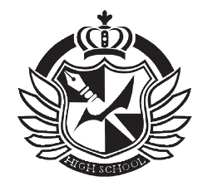
- Sample crest shown (shown opposite; size 5.4 cm x 5.7 cm)) is the actual size which will be printed on the JCPA cover page. Please ensure that your crest is of sufficient quality/resolution to render clearly at this size.

- Larger images will be accepted by the Department and will be resized to render clearly at the appropriate size.

- Images will be accepted as any image file (.jpg/.tiff etc)

- Where an image is sent to the Department with additional text (school name under, over or around the main image) then this will be removed by the Department.

- Please save the image as “YourSchoolCentreNumber”_Crest. (e.g. for school roll number 12345X the image should be named 12345X_Crest.jpg OR 12345X_Crest.tiff).

Signatures

- Where a school/centre for Education chooses, the Principal and/or Year head signature can be included on the JCPAs which will be generated by the system.

- In order to include the image then please:-
  - Complete the details as contained in the form below.
  - Scan the completed page and save the file as “YourSchoolRollNumber”_signature. (e.g. for school roll number 12345X the file should be named 12345X_signature.jpg OR 12345X_signatures.pdf).

Please forward both (i) Crest/Logo Image and (ii) Signature Image to JCPA@education.gov.ie in one single email as soon as possible before commencing the download process for your school

Any queries on this should be addressed to JCPA@education.gov.ie.

Signatures for inclusion in the JCPA
 | Name (block capitals) | Signature (please ensure signature fits within the container)
Signature

☐ Principal

☐ Year Head

Appendix 3 – Privacy Notice and Consent Form

PRIVACY NOTICE - Junior Cycle Profile of Achievement Award
For the information of parents/guardians of students who will receive a 2023 Junior Cycle Profile of Achievement (JCPA) award

Introduction

It is required by data protection law that before schools commence processing of any personal data a school must first bring a privacy notice on how the student’s personal data will be processed to the attention of parents/guardians. This privacy notice relates to those students who have undertaken Junior Cycle at Level 3, Level 2 or Level 1 of the National Qualifications Framework. Junior Cycle Level 3 includes exams set by the State Examinations Commission (SEC), where the provisional results are provided to schools and students in the September following the sitting of the State examinations. Junior Cycle Level 2 and Level 1 Learning Programmes are designed for students with particular special educational needs and is broadly aligned to Level 2 and 1 of the National Framework for Qualifications (NFQ) respectively. In some instances students will undertake a combination of a Level 1, 2 and Level 3 programme.
Process

This document sets out the information in relation to how students’ Junior Cycle assessment data will be used to produce the Junior Cycle Profile of Achievement (JCPA). The JCPA has replaced the Junior Certificate award.
Where student details are currently maintained on the Department’s Post-Primary Online Database (PPOD) the JCPA will be produced by schools via PPOD. Where student details are not held on PPOD (e.g. special schools) the JCPA will be produced via the Junior Cycle Assessment Database (JCAD).
Schools will be enabled to record additional assessment student data on PPOD or JCAD for the purpose of producing a Junior Cycle Profile of Achievement (JCPA) for each of their students who completes the Junior Cycle.

This approach enables

- schools to record on PPOD or JCAD the descriptors awarded in Classroom-Based Assessments in subjects and short courses and also reflect achievement in Priority Learning Units (PLUs) for students with special educational needs.
- the State Examinations Commission (SEC) to provide state examinations final results electronically to the Department of Education and Skills for upload to PPOD and JCAD and association of these results with each student.
- the Department of Education and Skills to provide the JCPAs electronically to schools/centres of education for each student.
- Schools/centres of education to complete the ‘other areas of learning’ section of the JCPA for each student and deliver the award to students. The ‘other areas of learning’ section of the JCPA allows the school/centre of education to report on other learning experiences and events that the student has participated in outside the formal timetabled curriculum. The data entered at school level for ‘other areas of learning’ will not be stored on the Department’s database.
- following production of the JCPA for each student the school/centre of education to retain a copy of the full JCPA for each student.
- the data to be anonymised once JCPAs are produced and used in statistical analysis. No identifiable individual data is used by the Department

It should be noted that only a small number of staff within the Department of Education has access to the personal data and then solely to provide technical support to your school/centre of education when it is using the PPOD or JCAD application.
Student data as set out below will not be shared with anyone else other than another post-primary school in which the student enrols.

Pursuant to Section 3 and Section 4 of the Data Protection Acts, you may access your personal data and request a copy of your data held on PPOD by contacting your school, or if you are a former student by contacting the Department of Education.
Under data protection law you may object to the processing of your data or seek to have the data corrected.

More detail on use of personal data by the Department is contained in the FAQ on PPOD available on https://www.education.ie/en/The-Department/Data-Protection/FAQ.html.

The Department of Education Data Controller for PPOD is the Principal Officer in the Parents, Learners and Database Section within the Department who can be contacted by e-mailing p-podhelpdesk@education.gov.ie

The Data Protection Officer for the Department may be contacted by e-mailing gdpr@education.gov.ie

List of post-primary student personal data recorded by post-primary schools on PPOD or JCAD for the purpose of producing the Junior Cycle Profile of Achievement (JCPA).
Sensitive Personal Data for some students with a special education need
- Priority Learning Unit descriptor
- Priority Learning Unit medium – Irish/English
- Priority Learning Unit outcome
Written consent should be sought from the parents/guardians of students with special educational needs (see template below).
For each subject where an examination held by the State Examinations Commission was taken
- Level taken in the final examination
- Outcome of Classroom-Based Assessments 1 and 2 (NB Only if recorded on PPOD)
- Predicted medium through which final examination taken Irish/English
- Overall grade awarded by State Examinations Commission
- Annotation of result to indicate a subject was assessed except for a particular element e.g. aural is missing
For each short course taken
- Title
- Level of Learning Programme - 2 or 3
- Medium Irish/English
- Outcome of Classroom- Based Assessment
In addition the following data provide by the State Examinations Commission will be printed on your JCPA
- Forename and Surname – as provided to the State Examination Commission
- Date of Birth – to aid identification whether there are more than two students with the same name
- State examination candidate number – to assist with any follow up query with State Examinations
Information on other personal data stored outside of PPOD and used by your school in producing your JCPA is available in your school’s Data Protection Policy a copy of which may be obtained from your school.
Information on the all other personal data of students collected and processed by schools using PPOD is available in the Fair Processing Note for PPOD copies of which are available at www.gov.ie

CONSENT FORM for the recording of assessment data relating to the Level 2 Learning Programmes and Level 1 Learning Programmes for students with particular special educational needs.

NAME OF SCHOOL _______________________________________________________

ADDRESS OF SCHOOL_______________________________________________________

NAME OF STUDENT _________________________________________________________

Date of Birth of Student ________________________________________________________

I consent to details of the outcomes of any Level 2 Learning Programmes and Level 1 Learning Programmes undertaken by the above named student being recorded on the Department of Education PPOD or JCAD computer applications in order that the above school may include this information on the student’s Junior Cycle Profile of Achievement (JCPA).

___________________________________
Signed

________________________________ _____________________
PRINT NAME DATE

Please return completed forms to the student’s school

This form should be retained by the school for the duration of the student’s enrolment and made available for inspection by an officer of the Department or the Office of the Data Protection Commissioner, if required.

Appendix 4 – Sample JCPAs

SAMPLE Level 3 JCPA

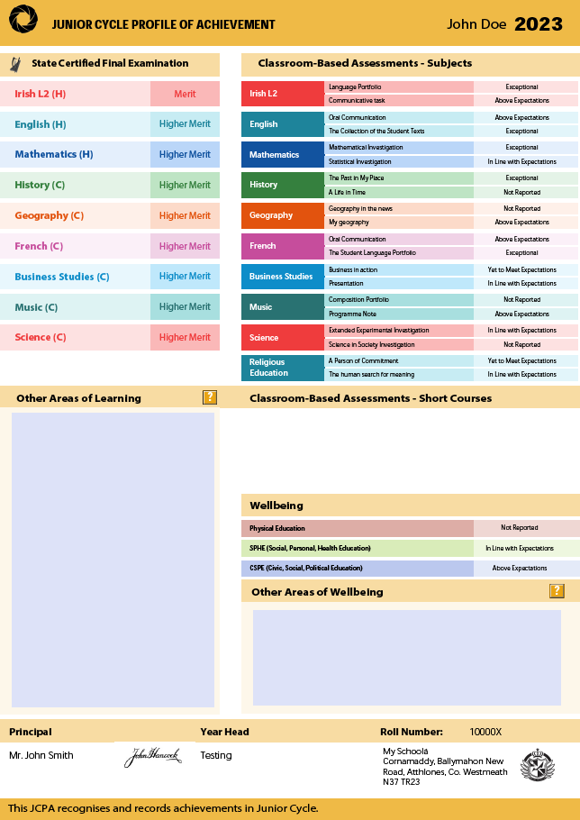
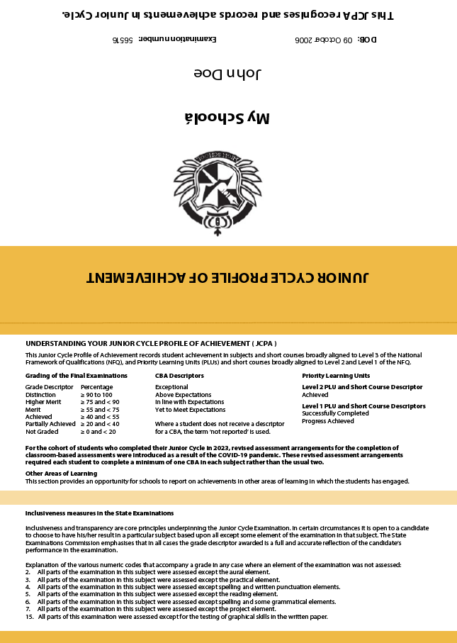

SAMPLE Level 2/3 JCPA

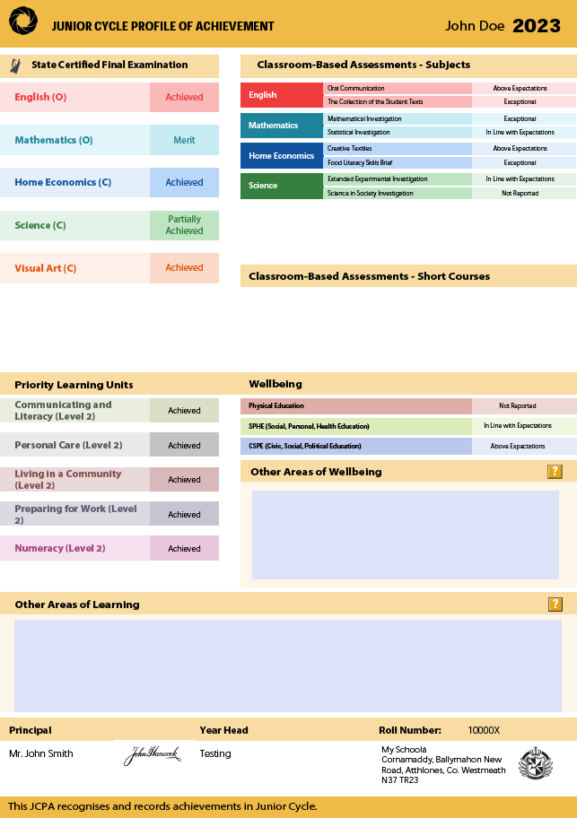

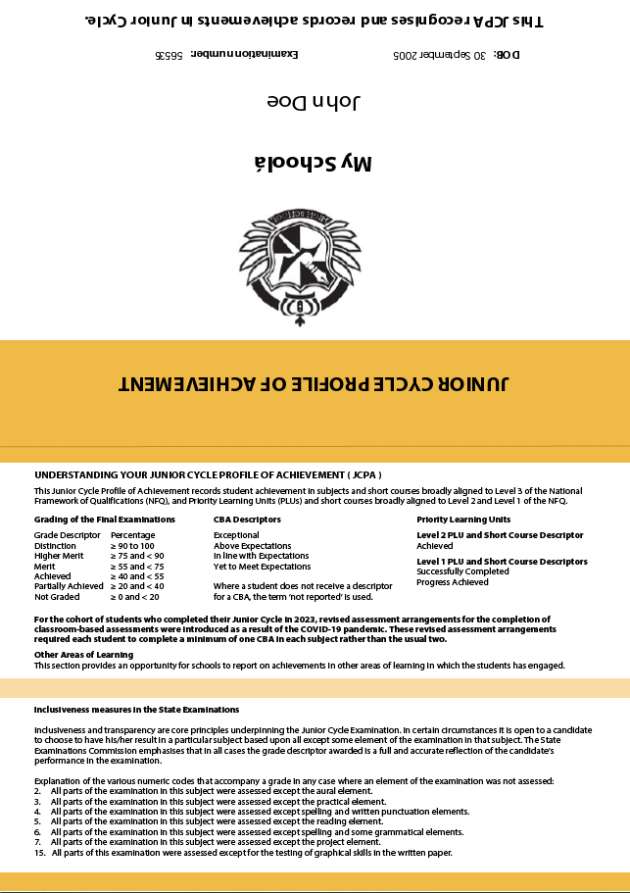

Sample Level 2 or 1 JCPA

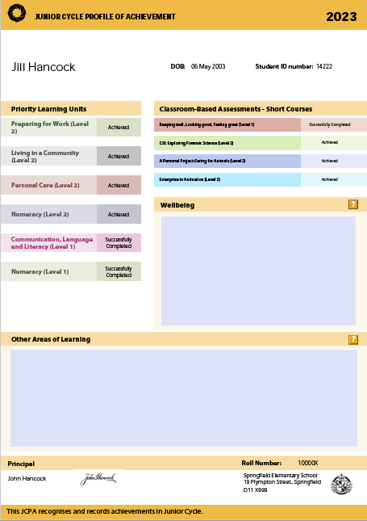
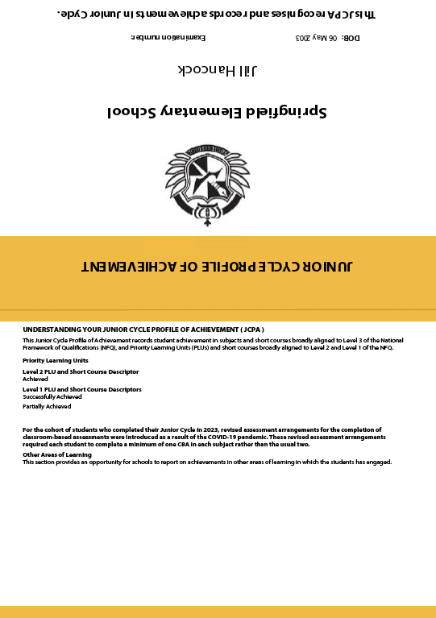

https://www.gov.ie/en/collection/7ab67f-post-primary-online-database-ppod-user-guides/
Please see separate Privacy Notice on general use of P-POD at https://www.gov.ie/en/service/43ddb5-post-primary-online-database-p-pod/
JCAD is the DE database developed to facilitate the production by Special Schools and Centres of Education of the JCPA.
Details on retention periods, legal basis for collection by the Department and the school are contained in the Fair Processing Notice for PPOD
Classroom-Based Assessments are part of the new specifications for English, Business Studies and Science.

