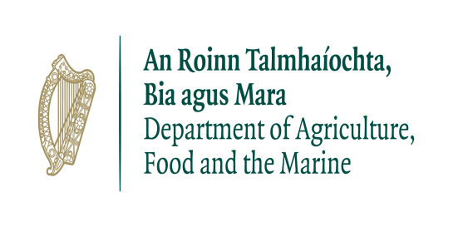

Agri-retailers/Co-ops Expression of Interest form to participate in the
Red Clover Silage Measure (RCSM) 2022 operated by the Department of Agriculture Food & the Marine.
Application details (to be submitted by the retailer):
Agri-retailer/Co-op Name: …………………………………………………………………………………………………………………….
Address: …………………………………………………………………………………………………………………………….
Phone Number: …………………………………
Name of person responsible for this measure: ……………………………………………………….
…………………………………………………………………………………………………………………………………………..
Mobile: ……………………………………………………………
E mail: ……………………………………………………………………….

Declaration:
I wish to apply to participate in the Red Clover Silage Measure 2022.
I have read, understand, and agree to abide by the Terms and Conditions of the Red Clover Silage Measure. In particular I agree to the following
- I undertake to maintain full records relating to the sale of all red clover silage seed mixture being sold under this measure. These records will include
- Invoice/sales receipts/statements, showing the number of bags and clearly indicating a discount has been applied to the price of each bag of red clover silage seed mixture being sold to each approved farmer.
- Records of payments and customer’s statements, and any other relevant documentation.
- In respect of each purchase of red clover silage seed mixture, the approved applicant’s Sales Declaration Form will be signed and certified at the time of purchase by the approved farmer and the participating retailer as the basis for a claim for reimbursement to the Department.
- I undertake to return all documentation to the Department as part of my claim for payment. Documentation to include Invoices/Receipts/Statements etc showing discount has been applied to each bag of red clover silage seed mixture purchased along with each approved participant’s completed Sales Declaration Form.
- I undertake to collate the details of all the sales of red clover silage seed mixture to farmers in the Sales Declaration Form and to submit a single Excel sheet form (template to be provided by the Department of Agriculture, Food and the Marine) electronically to the Department as the claim for reimbursement under the terms of the Measure at up to two times during the lifetime of the measure i.e., by mid- June and by 1st October 2022.
- I undertake to deduct the full value of the Department’s contribution towards the cost of the red clover silage seed mixture. This deduction must be fully and clearly reflected in the price charged to the Approved Applicant.
- I am aware of my obligations under the Data Protection Laws with respect to security, of the personal data supplied to me.
- This data will be returned to the Department of Agriculture, Food and the Marine as part of my claim for payment and is not to be shared with any 3rd parties.
- I agree to take all reasonable precautions to preserve the integrity of any Personal Data which is processed on the Red Clover Silage Measure and to prevent any corruption or loss of such Personal Data.

Name (Block Capitals) ……………………………………………………………………. Manager/Director/Company Secretary
Signature……………………………………………………………………………….
Date………………………………….
Official company stamp to be included here:

Please return a scanned copy of the completed form by email to rcsm@agriculture.gov.ie and indicate expression of interest in the subject line, or post the original to:
Red Clover Silage Measure,
Nitrates & Biodiversity Division,
Department of Agriculture Food & the Marine,
Johnstown Castle Estate,
Wexford,
Y35 PN52

Expression of Interest Forms must be returned to the Nitrates & Biodiversity Division by the 14th April 2022.

