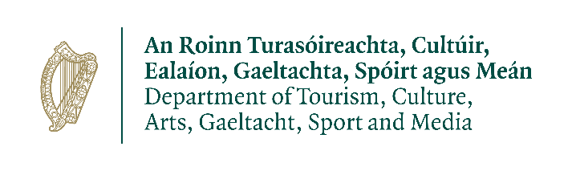
Arts and Culture Recovery Oversight Group Meeting

29th September 2021 @ REMOTE LOCATIONS
Attendees
List of attendees by video conference:
Conor Falvey, Assistant Secretary, Chair
Sharon Barry, Principal Officer, Cultural Supports Unit
Simone Barnett, Assistant Principal Officer, Cultural Supports Unit,
Doire Ó Cuinn, Strategic Policy and Project Services Unit
Maureen Kennelly, Director, Arts Council
Claire Pike attended on behalf of David C Hegarty
Brian O’Malley, Assistant Secretary, Department of Public Expenditure and Reform
Seán Mc Glinchey, Executive Officer, Cultural Supports Unit

Apologies
David Hegarty, Assistant Secretary, Department of Enterprise, Trade and Employment
Pat Dowling, Chief Executive, Clare County Council, CCMA Representative
Niamh O’Doherty, Administrative Officer, Cultural Supports Officer
Tristan Vaughan, Strategic Policy and Project Services Unit

Agenda

- Presentation by Martin O'Rourke from Equity
- Update on the 10 recommendations
- Update on the Options Paper
- AOB

Minutes
- Minutes of the Last Meeting. The minutes of the last meeting were agreed.
- Update on the 10 recommendations: CSU gave an update on the on the progress of the 10 recommendations on the Live Worth Living Report. A draft report on the recommendations will be issued next week.
- Update on the Options Paper
- CSU will meet with the Minister next week to present the options.
- AOB – None
Action Points:-
- Draft recommendation report to issue next week.
- Updated policy paper on BI to issue next week.
- The presentation from Equity did not go ahead due to technical issues on their side. The presentation will be rescheduled for the next meeting.

