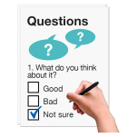

Disability Action Plan 2022 to 2025
Survey Form

Question 1 - Are you?
 |  | Yes | No
 | A person that uses or needs disability services
 | The family member of a child or adult who uses or needs disability services
 | A member of a disability organisation or group

Question 2 – Are you filling in this form as?
 |  | Yes | No
An individual
I am giving my own views
For an organisation
I am giving the views of the organisation

If you are filling in the form for an organisation, what is the name of your organisation?

Question 3 – Are you?
 |  | Yes | No
 | A man
 | A woman
 | Other
 | I would prefer not to say

Question 4 – What county do you live in?

Do you live in?

 |  | Yes |  | No
 | A city
 | A town
 | The countryside

Question 5 – Tick the box to show the services you get.

 |  | I don’t need this | I need but don’t have this | I have this | I have this but I need more
 | Early services for young children
 | Therapy services for children
 | Therapy services for adults
 | Day services
 | Rehab Training
 | A Personal Assistant
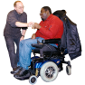 | Home support or home help
 | Respite and short breaks
 | Supported housing or residential place
 | A move to a house in the community
 | Assistive technology
 | Support from organisation that helps people with a disability
Other: Please write here

Question 6 – Tick the box to show the therapy services you need.

 |  | I don’t need this | I need but don’t have this | I have this but I need a bit more | I have this but I need a lot more
 | Speech and Language Therapy
 | Occupational Therapy
 | Physiotherapy
 | Psychology
 | Social Work
 | Behaviour Support Worker

 |  | I don’t need this | I need but don’t have this | I have this but I need a bit more | I have this but I need a lot more
 | Dietician
 | Nurse
Other therapy support
Please say which:

Question 7 – What services and supports do you think you might need in ten years’ time?
Write your answer in here

Question 8 – Tell us how you think services are working at the moment. Are they good quality?

 |  | Bad | Okay | Good | Excellent
 | Early services for young children
 | Therapy services for children
 | Therapy services for adults
 | Day services
 | Rehab Training
 | A Personal Assistant
 | Home support or home help
 | Respite and short breaks
 | Supported housing or residential place
 | A move to a house in the community
 | Assistive technology
 | Support from organisation that helps people with a disability

Write in here if you want to say more about services that are working well and not working well.
If you have ideas about how things could change, tell us here.

Question 9 – What is the most important?

Tick the box to say what you think is the most important for the next four years.

 | Disagree | Neither agree nor disagree | Agree
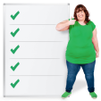

The Government should try to make all disability services better.

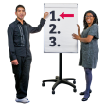

The Government should work more on some areas of disability services than others.

 | Disagree | Neither agree nor disagree | Agree
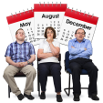

Waiting lists for disability services are a bigger problem than the quality of services.

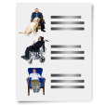

There are not enough
disability services.
Fixing this is more important than making services better.

Question 10 – Tick the top three Disability Services that you think the Government should give extra money to.

Early services for young children
Therapy services for children

Please say which therapy services

Therapy services for adults

Please say which therapy services

Day services
Rehab Training
Personal Assistants

Home support or home help
Respite and short breaks
Supported housing or residential places
Moving people from a large care setting to a house in the community
Assistive technology
Giving supports from organisations that help people with a disability

Other: Please write here

them in here.

If you have any other ideas, please put them in here.

Write your answer in here

Thank you for sharing your views and ideas.

